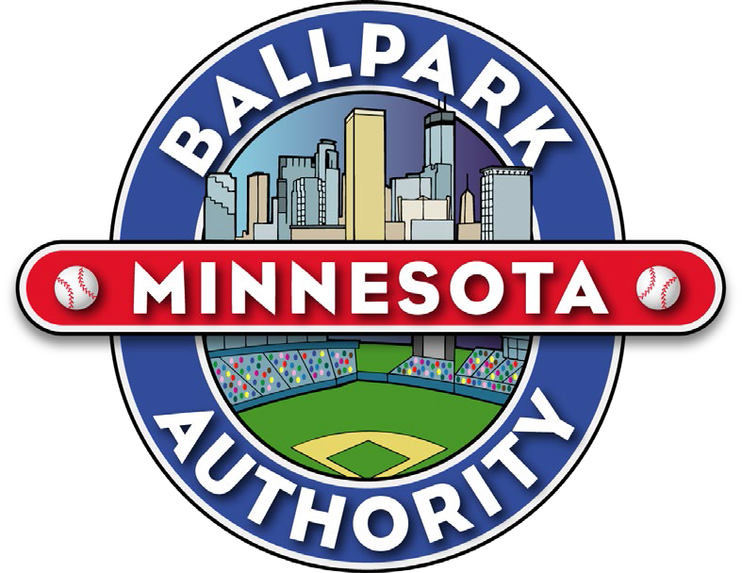

Minnesota Ballpark Authority Board Meeting Minutes – April 16, 2026

Chair Margaret Anderson Kelliher called the board meeting of the Minnesota Ballpark Authority for April 16, 2026, to order at 2:00 p.m. The roll was taken. Commissioners Justin Baylor, David Ybarra, Charlene Briner, and Dave Lawless were present.

Commissioner David Ybarra moved approval of the agenda, seconded by Commissioner Dave Lawless, and approved unanimously – 5 YEAS, 0 NAYS.

APPROVED

Commissioner Justin Baylor moved approval of the January 15, 2026, meeting minutes seconded by Commissioner Dave Lawless and approved unanimously – 5 YEAS, 0 NAYS

APPROVED

Public Comment – No public comment

Chair’s Report – Chair Margaret Anderson Kelliher stated that the Personal Evaluation of Executive Director Dan Kenney will be held at the end of the meeting.

Executive Director’s Report – Executive Director Dan Kenney gave an update on the discussion at the Legislature to shift most of the ballpark sales tax to support Hennepin County Medical Center while allowing some funding for future ballpark capital improvements, as part of a 20-year lease extension. There is support for this measure in the Minnesota House and Senate but continued discussion on what the sales tax rate should be in the final bill language.

DISCUSSION ITEMS

Twins Correspondence – Dave Horsman, Senior Vice President Ballpark Operations
Mr. Horsman briefed the Commissioners on the letters of correspondence from the Twins.

Target Field Operations Update – Dave Horsman, Senior Vice President Ballpark Operations Mr. Horsman reported that because of the power outage on Opening Day, another smaller version of Opening Day festivities is being planned for April 17th. There are many non-game day events and concerts scheduled for this summer. Major events happening in August are the Noah Kahan concert on August 5th, Savannah Bananas August 7-9, the Twins vs the Philadelphia Phillies in the Field of Dreams game on August 13th in Dyersville, Iowa, Tim McGraw, The Chicks and Lady A on August 23rd and My Chemical Romance on August 24th. Perimeter security improvements are ongoing and work will be done on the 5th Street side of the ballpark through the summer. A mural celebrating Black Baseball in Minnesota will be officially unveiled on Monday, April 27th on the Concourse at Section 114.

Gary Glawe, Senior Director of Facilities - Mr. Glawe stated that the building came through winter very well. The power failure on Opening Day was the first in 17 years, but there are procedures in place for when something like this happens and the opportunity to use these procedures went well. There were no injuries and power was restored in an hour.

Financial Report – Brenda Juneau, MBA Finance Coordinator - Ms. Juneau reported on the Financial Summary for 2025. As of the end of the 2025 fiscal year, MBA governmental funds reported combined ending fund balances of $22,171,790, a decrease of $3,097,615 from the prior year. The decrease resulted from the higher capital outlay expenditures in 2025. There is an outstanding invoice for auditor services for 2025 and there is a budgeted amount of $10,000 in the Operating Fund for 2025. This amount could increase to $13,000 for the year, which would require an amendment to the budget.

Personal Evaluation

Meeting adjourned at 2:37 p.m. for Closed Executive Session – Performance Evaluation of Executive Director, Dan Kenney.

Reconvened meeting at 2:45 p.m. for Summary of Conclusions of Evaluation and Resolution.

4-16-26 Resolution 26-MBA-226

Purpose:

To authorize the Chair to execute an amendment to the employment agreement with the Executive Director of the Authority.

Background:

On August 18, 2006, the Minnesota Ballpark Authority entered into an employment agreement with Dan Kenney, Executive Director of the Authority. Among other terms and conditions, the agreement states that each year of the Executive Director's employment, the Authority shall review and may adjust the Executive Director's base salary in its sole discretion. This resolution authorizes the Chair to enter into an amendment to that agreement.

Action Requested:

BE IT RESOLVED that the Minnesota Ballpark Authority authorizes the Chair to enter into an amendment to the Employment Agreement with the Executive Director with the following terms:
- Base Salary: Increase the annual base salary to an annual base salary of
$219,606.44, effective January 1, 2026.

- Employment Term: Extend the term of employment through August 21, 2027.
- Memorialize past practice since 2021 of recognizing Juneteenth as a legal holiday.
- All other terms and conditions of the employment agreement remain the same.

There being no further business, Chair Anderson Kelliher adjourned the meeting at 2:48 p.m. Next meeting: July 16, 2026

